Menu Bar

Make it marked portion centered

Slider

Email: info@devpolymer.com
Call: +91-9910295765

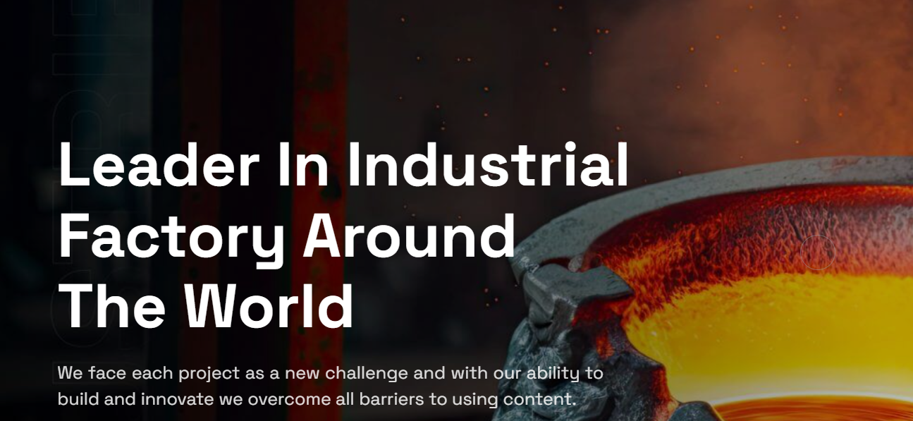

Slider 1 - FRLS-FR Compound
Title: Raising Fire-Safe Standards Across Cable Systems
Description: Our FRLS-FR compounds are engineered to reduce flame spread, minimise smoke emission and ensure dependable performance, supporting safer electrical installations across demanding commercial and industrial environments.

Slider 2 - Sheathing Compounds
Title: Durable Sheathing Compounds for Tough Applications
Description: Engineered for abrasion resistance and long-term protection, our sheathing compounds ensure reliable cable integrity across varied mechanical and environmental conditions.

Slider 3 - Transparent Compounds
Title: High-Clarity Compounds for Precision Cabling
Description: Designed for exceptional clarity and insulation stability, our transparent compounds support applications requiring visual inspection, flexibility and consistent electrical performance.

4 Boxes

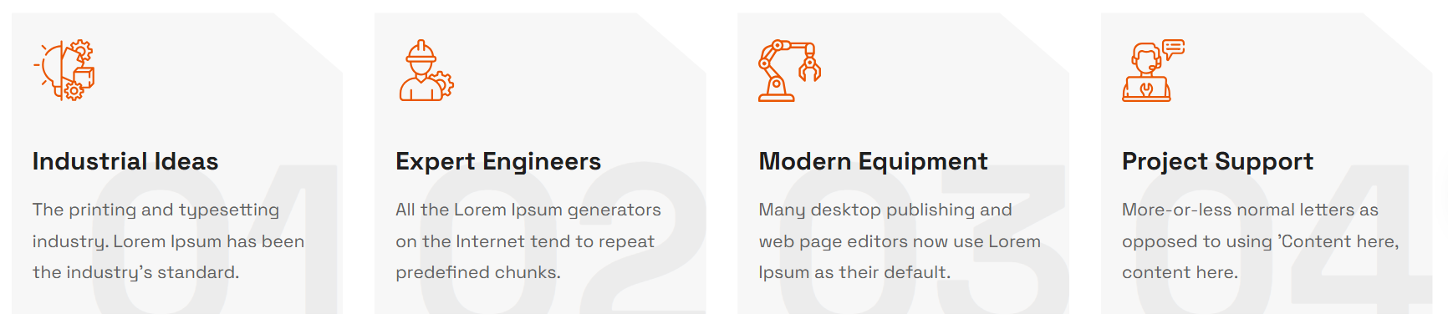

- Polymer Precision
Reliable PVC compounds formulated for consistent performance across diverse cable needs.

- Skilled Experts
Experienced specialists ensuring consistent quality and innovation in every compound.

- Modern Solutions
Cutting-edge PVC processing ensures safe, efficient and long-lasting performance.

- Trusted Support
Trusted partner offering consistent supply and customized compound solutions.

About US



We work for you since 1989. Industrial around the world. We innovate for you since 2004. Precision Polymers Powering Industry.

Welcome to Industrie, a leading industry innovator with a rich history of excellence. DEV Polymer delivers engineered PVC compounds trusted across critical cable sectors.

At the heart of the global landscape, the industry stands as a multidimensional force of progress, driving economies. Our compounds enhance performance, ensure stability and support vital applications across expanding industrial networks.

Running Numbers


(make the numbers and text centered to line)

20+ Years Expertise
03 Manufacturing Units
50+ Quality Checks
98% Timely Delivery

Our Products

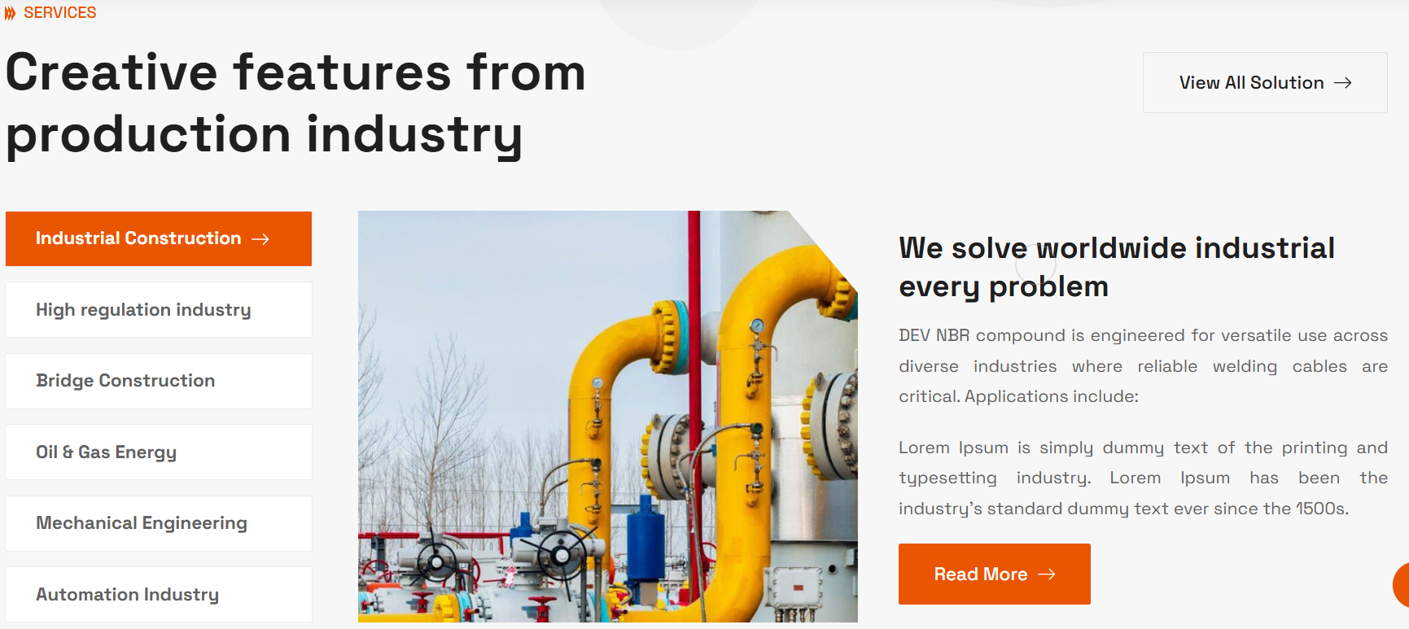

SERVICES Our Products

View All Solution Discover a

Product 1 - Sheathing Compound
Title: Durable Sheathing Compounds for Reliable Cable Protection
Description: Our Sheathing compounds offer consistent mechanical strength, stable insulation and strong resistance to weathering, chemicals and abrasion.
Engineered for house wiring, industrial power lines and communication cables, they ensure dependable cable protection across varied installations and demanding operational conditions.

Product 2 - Insulation Compound
Title: Advanced Insulation Compounds for Reliable Cable Safety
Description: Our Insulation Compounds deliver consistent dielectric strength, thermal stability and flame resistance for house wiring, industrial cabling and automotive circuits.
Designed for varied voltage classes, they ensure uniform flexibility, secure conductor protection and long-term reliability across diverse electrical environments.

Product 3 - FRLS & FR Compound
Title: High-Safety PVC Compounds for Flame-Critical Cabling
Description: Our FRLS and FR compounds provide controlled flame propagation, reduced smoke emission and stable performance under thermal stress.
Engineered for residential, commercial and industrial wiring, these formulations enhance fire safety, maintain insulation integrity and ensure dependable operation across high-risk electrical environments.

Product 4 - Transparent Compound
Title: Clear, Durable Compounds for Demanding Applications
Description: Our transparent compound offers strong weather resistance, metal-corrosion protection and stable electrical insulation.
Its abrasion tolerance, lightweight structure and long-term clarity support outdoor cables, specialty wires and high-fidelity signal systems requiring dependable conductivity in varied operating conditions.

Product 5 - Welding Compound
Title: Resilient NBR Compounds for High-Load Welding Cables
Description: Our welding cable compounds deliver rugged flexibility, heat endurance and abrasion stability essential for heavy-duty welding lines.
Their NBR-based formulation supports consistent current flow, impact resistance and long life, ensuring reliable performance in fabrication units, industrial workshops and high-load mechanical environments.

Product 6 - Gabion Compound
Title: Durable PVC Compounds Built for Gabion Stability
Description: Our Gabion PVC compounds are engineered for long-term exposure to soil, moisture and harsh weather cycles.
Their strong adhesion, UV stability and abrasion resistance ensure coated gabion wires retain structural integrity, corrosion protection and reliability across infrastructure, slope protection and heavy civil engineering applications.

Work Process


(keep the title also justified – bold one and put the relevant icons)

01. Requirement Analysis and Performance Benchmarking
We evaluate cable specifications, thermal demands and electrical needs to define exact compound behaviour for reliable end-use performance.

02. Precision Formulation and Compound Engineering
Our team designs targeted PVC blends, refines mechanical and dielectric properties and ensures consistent output through controlled processing.

03. Controlled Production and Quality Assurance
Compounds are manufactured on calibrated lines and validated through rigorous tests to guarantee stable, application-ready cable performance.

Industries We Serve

RECENT WORK INDUSTRIES WE SERVE

Explore Large-Scale Projects Advanced Compounds for Demanding Sectors
(make the content justified)

(Images Attached in the folder)

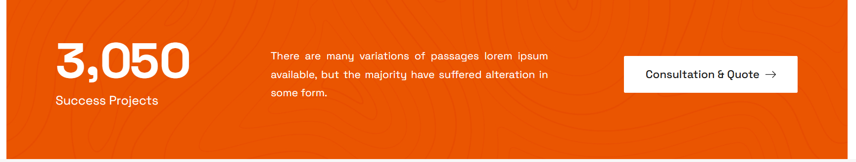

3,050 Success Projects 300+ Trusted Clients
There are many variations of passages lorem ipsum available, but the majority have suffered alteration in some form. Trusted by cable manufacturers for precision PVC compounds engineered to endure stress, maintain durability and meet strict performance needs.

Testimonials



Remove More Reviews Box, Logo and Photo inside the review box

What people say about Industrie company What industry leaders say about DEV Polymer?
(make it in one line only and make the content justified)

- We shifted all our sheathing grades to DEV Polymer because their tensile strength and consistency outperform our earlier suppliers.
— Vipin Khatri, Khatri Electricals
Star 5

- What I value most is batch-to-batch consistency. Makes planning and production completely predictable.
— Deepak Malhotra, Malhotra Wirelinks
Star 4.5

- Their PVC transparent compound delivers excellent clarity and signal purity, perfect for our premium audio cables.
— Prateek Sabarwal, Sabarwal SoundLines
Star 4

- DEV Polymer’s solar cable compounds show outstanding outdoor stability. UV ageing tests exceeded our expectations.
— Vikas Goel, VG Solar Manufacturer
Star 5

- DEV’s FR compounds helped us achieve better fire test results without compromising flexibility.
— Harish Chhabra, Chhabra Wire House
Star 4

- DEV Polymer’s FRLS compounds improved our wire performance significantly. Clean extrusion and consistent batch quality.
— Rajesh Arora, Arora Cable Works
Star 5

- We shifted to their Type C compound for heat-resistant cables. Noticeable improvement in dielectric strength.
— Suresh Jain, Jaincore Electricals
Star 4.5

- The durability of their NBR compound helped us achieve better abrasion resistance for heavy-duty applications.
— Deepak Suri, Suri Traders
Star 5

Blogs & Insights



UPDATE BLOGS & INSIGHTS

Articles & blog posts with useful information Technical Insights & Industry Trends for Polymer Innovation
(make the content justified)

Footer

Current DEV Polymer is a leading PVC compound manufacturer delivering high-performance FRLS, insulation, sheathing, solar cable compounds with 10,000+ tons annual capacity, powering industries with innovation and reliability.

New DEV Polymer delivers advanced PVC compounds for FRLS, insulation, sheathing and solar applications. With over 10,000 tons annual capacity, we power industries with engineered reliability, consistent quality and proven material performance.

SEO Meta Data

Meta Title: Leading PVC Compound Manufacturer in Delhi | DEV Polymer

Meta Description: DEV Polymer manufactures 10,000+ tons annually of premium PVC and cable compounds for automotive, solar and electrical industries across India.

Meta Tags: PVC Compound Manufacturer Delhi, Automobile Cable Compound, FRLS PVC Compound, PVC Transparent Compound, PVC Insulation Compound, Sheathing PVC Compound, Solar Cable Compound, Welding Cable Compound, Polymer Compounding India, Industrial PVC Manufacturer, Cable Compound Supplier India, Best PVC Compound Manufacturer, Delhi Polymer Factory, Cable Grade PVC Compound, Customized Polymer Solutions, PVC Granules Supplier, Industrial Cable Materials, Electrical Cable Compound Manufacturer

